Game Design

# RuftLauser

## Game Mechanics

The game places you in the cockpit of a WW2 aircraft thrust into combat as a fighter ace. You as your countries greatest fighter pilot are tasked with destroying the enemy air force. It will only be you, the fighter pilot ace verses the entire enemy force.

## Core Gameplay

The core gameplay will consist of a 2D sides-scroller type shooter which the player will be able to fly in and shoot down other flying enemies and strife naval enemies. Items such as bombs will periodically drop and will allow the player to use bombs to either take out large ships and even some large aircraft.

## Game Play Elements

Basic mechanics such as a 2D side-scroller based physics will be used for all flying objects such as enemy planes and the player. There will also be a projectile system which all the enemies and the player will use. A bomb system in which a projectile with no propulsion (unlike bullets) will be used by the player.

The game will measure player progress in the score that they will get. The score is affected by the enemies that the player kills. Enemies will have a certain base point number which, if an enemy is killed, will add to the players score.

## AI

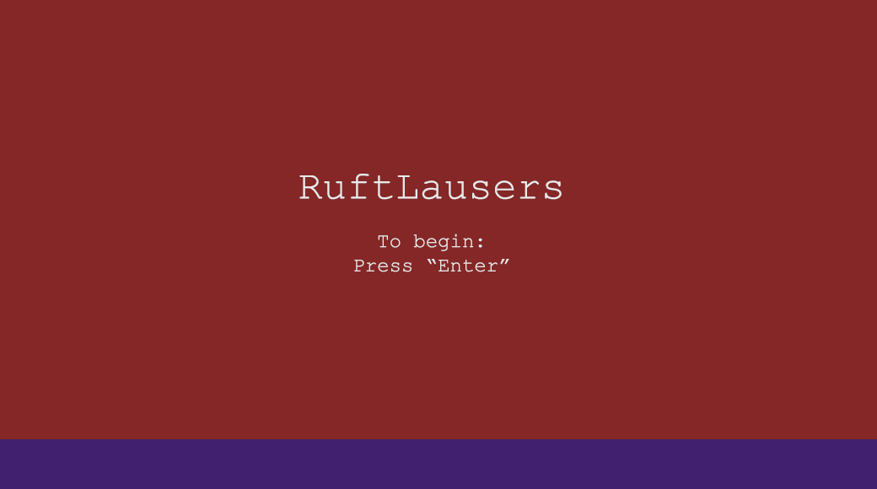The AI will only have one objective and that is to kill the player. It will simply shoot the player and depending on what type of unit it is, will either follow the player around and peruse them (an air unit), simply fly straight into the player (an enemy missile) or a simply aim and fire from a stationary position (heavy ground cannons).

## Function Requirements

The player upon starting the game will put into the start screen. The start screen will consist of a static version of the world seen during the gameplay without the player, enemies or bullet/missiles. Pressing the “Enter” key will launch the player out of the sky and immediately beginning the game where normal gameplay will occur. If the player gets killed during gameplay, the game will then display the final score of the player and will prompt them to restart to the start screen. In between these states will be minor game states that will be used in between the game over screen and the start screen. A game value reset state will be called as the game state changes between game over to the start screen which will reset the player position, all the enemies, removing all the bullets and resetting the time, score and player health. The game state will then proceed to the start game screen.

Main Menu Mock-up Screen

## 2D Art & Animation

### GUI Objects

There will be several elements that will be displayed on the screen. One such element is the health of the player which will be represented as a solid bar above the player score. The score is another element that will track the number of kills the player gets by adding the base score value of the killed unit to the score. A count-up time will also be displayed to show how long the player has survived the onslaught of enemies.

### Animation

The animations will utilize a sprite sheet for every dynamic object in the game (the player, enemy, explosion, etc.) which will allow the illusion of movement in a 2D plane.

### Sound and Music

The sounds that will play in the game will consist of effects such as gun fire, explosions, crash effects and ambient airplane engine noises that will be used by both the player and the enemy’s. A score sound will also be used to indicate that score has been added after each kill.

### Level Design

The level design will be quite simple, consisting of only flat ocean and a single island. Hitting the ocean or island will result in a crash and an instant death.

## Overall Goals

The overall goal is to create a simple 2D bullet hell arcade style shooter with dynamic sounds. The game does not have any saves as well as not lives so death would result in a complete restart.